**DAILY ONLINE ACTIVITIES SUMMARY**

|  |  |  |  |  |  |  |  |  |
| --- | --- | --- | --- | --- | --- | --- | --- | --- |
| **Date:** | **20/05/2020** | | | | | **Name:** | **Prashant Rama Bhat Kodlekere** | |
| **Sem & Sec** | **4th sem (B sec)** | | | | | **USN:** | **4AL18CS060** | |
| **Online Test Summary** | | | | | | | | |
| **Subject** | | **Object Oriented programing** | | | | | | |
| **Max. Marks** | | **30** | | **Score** | | | **18** | |
| **Certification Course Summary** | | | | | | | | |
| **Course** | **Data structure and algorithms** | | | | | | | |
| **Certificate Provider** | | | **Udemy** | | **Duration** | | | 28.5 total hours |
| **Coding Challenges** | | | | | | | | |
| **Problem Statement: Given an array a[] of size n which contains elements from 0 to n-1,**  **write a program printDuplicates which prints the duplicate elements of the given array. If no**  **duplicate element is found print -1.** | | | | | | | | |
| **Status:Completed** | | | | | | | | |
| **Uploaded the report in Github** | | | | | **YES** | | | |
| **If yes Repository name** | | | | | **https://github.com/prashantkodlekere/codingactivity** | | | |
| **Uploaded the report in slack** | | | | | **YES** | | | |

Online Test Details: (Attach the snapshot and briefly write the report for the same) 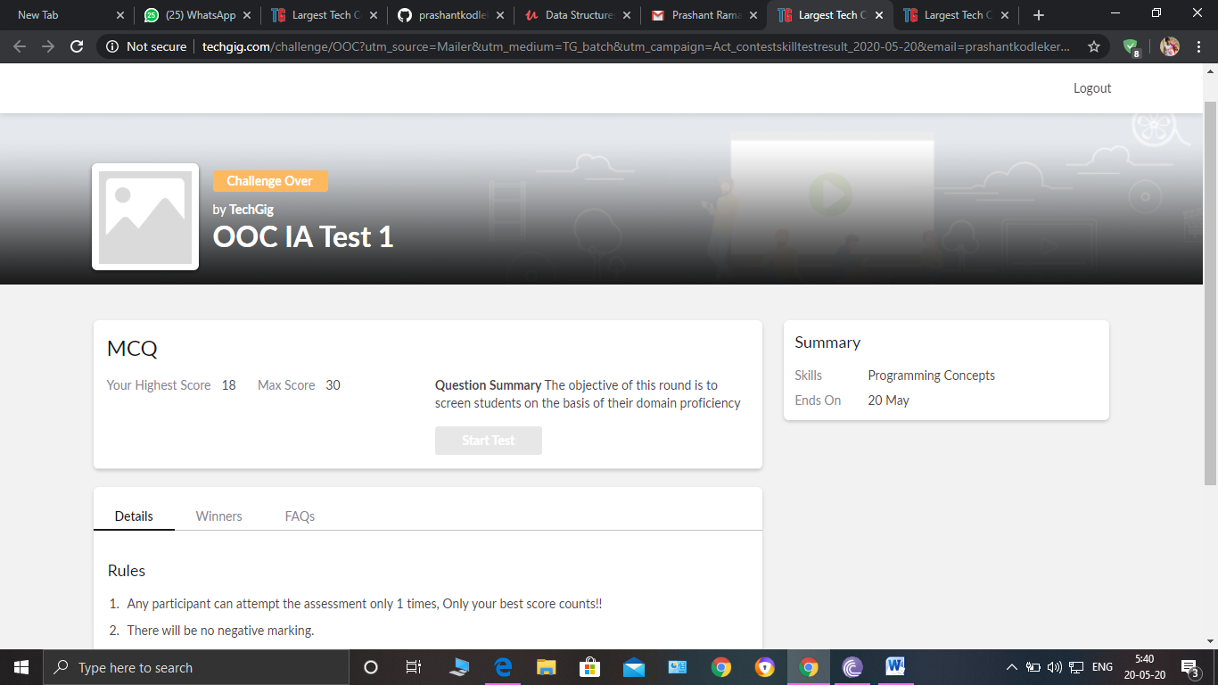

Object Oriented Concept Internals was conducted. A total of 30 questions were there in

which 20 of them were Multiple Choice Questions and 10 questions were programming based questions.

The above snapshot is the result sheet which was mailed to us by the Techgig team.

Certification Course Details: (Attach the snapshot and briefly write the report for the same) 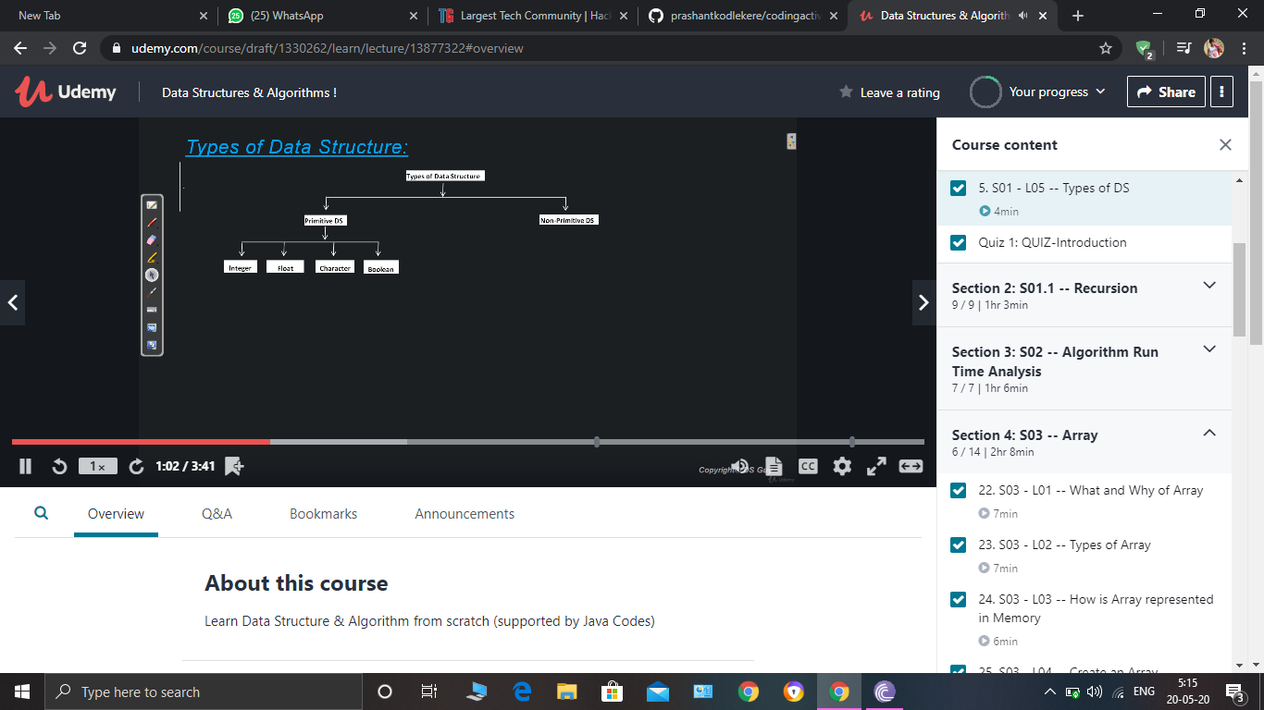

I learnt the course breakdown..and got to know what is DataStructures and Algorithms..and got to know that Problem solving is very important that helps in placement interviews and companies that ask DS and algorithms. I learnt how Data structures can be used in Daily life and also studied the types of Data structures...

Coding Challenges Details: (Attach the snapshot and briefly write the report for the same) 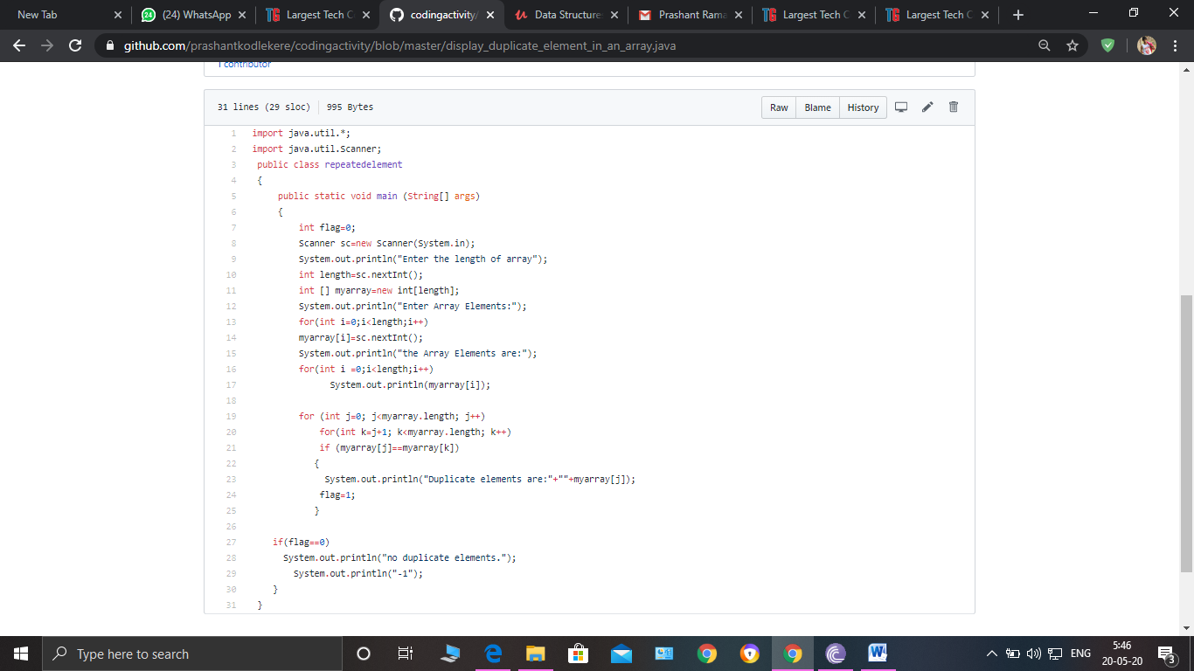

**The question I took to code is:**

Given an array a[] of size n which contains elements from 0 to n-1, write a program

printDuplicates which prints the duplicate elements of the given array. If no duplicate

element is found print -1.

Code: The above snapshot is the code which I have uploaded in my Github repository.